Lab Exercise Report 2_2
Student Name: Nguyễn Việt Hoàng
Student ID: B22DCVT214
Date of Submission: 25/09/2025

Proof that my code can run:
Case 1: 1 of the three password is correct
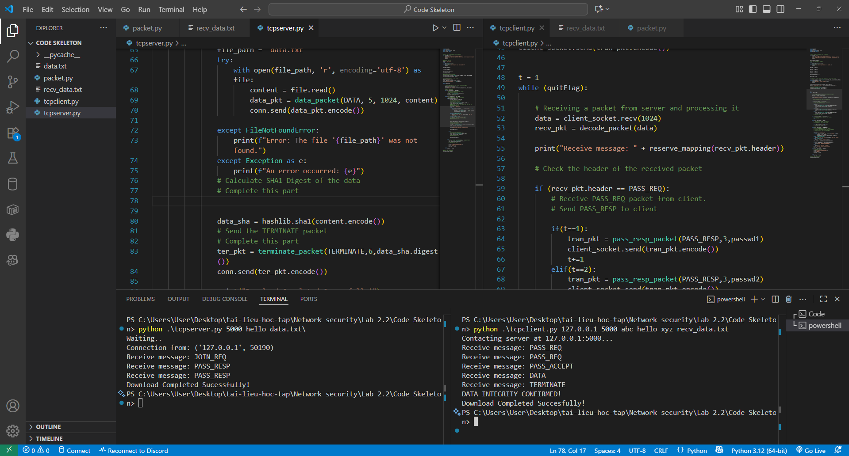
Note:
- When client side start running, it connect to the server at the IP address 127.0.0.1 and port 5000. After connected to the server, it send the JOIN_REQ message
- When the server side receive the JOIN_REQ message, it send the PASS_REQ back to the client
- When receive the PASS_REQ, client side then send a PASS_RESP message with a password
- When receive the PASS_RESP, the server the take the password from the message and compare to the correct password. Since the first pasword is not correct, the server response with another PASS_REQ
- When receive the PASS_REQ, the client resend another PASS_RESP with the next password
- Since the second password is correct, the server send a PASS_ACCEPT to the client
- Then the server read the data.txt file, and send a DATA packet with the file content
- After that, the server side use hash to digest the content, and send it in the terminate_packet
- After receiving the terminate_packet, the client side first digest the content receive in the data and compare it to the digested message in the terminate_packet
- After comparing, since the 2 message is the same, client side print “DATA INTEGRITY CONFIRMED!”
- Then the connection is cut from both side
Case 2: All three password is incorrect
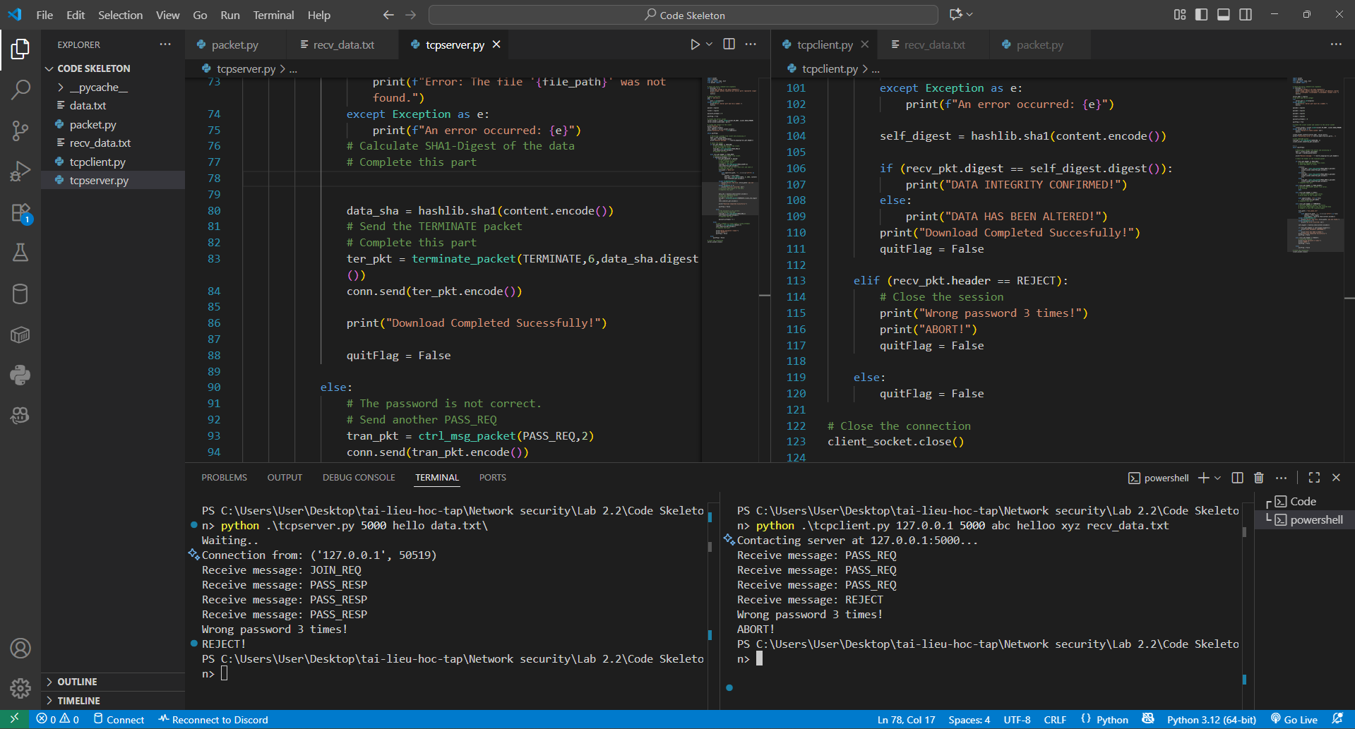
Note:
- When client side start running, it connect to the server at the IP address 127.0.0.1 and port 5000. After connected to the server, it send the JOIN_REQ message
- When the server side receive the JOIN_REQ message, it send the PASS_REQ back to the client
- When receive the PASS_REQ, client side then send a PASS_RESP message with a password
- When receive the PASS_RESP, the server the take the password from the message and compare to the correct password.
- Since all 3 password is incorrect, the server keep sent PASS_REQ, and the client keep reponse with PASS_RESP. After the third try, the server sent the REJECT message, and both side terminate the connection

